**Components Required:**

1. STM32F103C8T6 STM32 Microcontroller Board  
2. USB-TTL Converter/FTDI  
3. Breadboard  
4. Connecting Wires

**STM32F103C8T6 STM32 (Blue Pill) Board:**

Before Getting Started with STM32 Microcontroller, we need to know about STM32. The datasheets of STM32 contains all the information. Some of the information is explained below:

**Introduction:**

The STM32 family of microcontrollers from STMicroelectronics is based on the ARM Cortex-M 32-bit processor core. The STM32 series are some of the most popular microcontrollers used in a wide variety of products. They also have an excellent support base from multiple microcontroller development forums.

[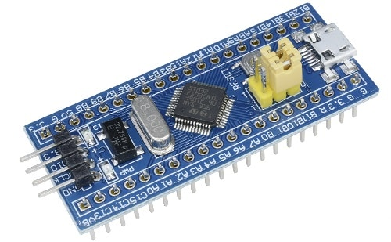](https://how2electronics.com/wp-content/uploads/2019/02/stm32.jpg)

STM32 microcontrollers offer a large number of serial and parallel communication peripherals which can be interfaced with all kinds of electronic components including sensors, displays, cameras, motors, etc. All STM32 variants come with internal Flash memory and RAM.

The range of performance available with the STM32 is quite expansive. The board also holds two crystal oscillators, one is an 8MHz crystal, and the other is a 32 kHz crystal, which can be used to drive the internal RTC (Real Time Clock). This enables the MCU to operate in deep sleep modes making it ideal for battery-operated applications. There are also two on-board LEDs, one (red color) is used for power indication, and the other (green color) is connected to the GPIO pin PC13.

**STM32F103C8T6 Full Form & Meaning:**

“Blue Pill” or STM32F103C8T6 name has a meaning behind it.

**STM** – stands for the manufacturer’s name STMicroelectronics  
**32** – stands for 32-bit ARM architecture  
**F103** – stands to indicate that the architecture ARM Cortex M3  
**C**– 48-pin  
**8** – 64KB Flash memory  
**T** – package type is LQFP  
**6** – operating temperature -40°C to +85°C

**Specifications:**

**Manufacturer:** STMicroelectronics  
**Product Category:** ARM Microcontrollers MCU  
**Mounting Style:** SMD/SMT  
**Core:** ARM Cortex M3  
**Data Bus Width:** 32 bit  
**Maximum Clock Frequency:** 72 MHz  
**Program Memory Size:** 64 kB  
**Data RAM Size:** 20 kB  
**ADC Resolution:** 12 bit  
**Number of I/Os:** 37 I/O  
**Operating Supply Voltage:** 2 V to 3.6 V  
**Operating Temperature:** – 40 C to + 85 C  
**Interface Type:** CAN, I2C, SPI, USART, USB  
**Program Memory Type:** Flash  
**Number of ADC Channels:** 10  
**Number of Timers/Counters:** 3 Timer

**Pin Details:**

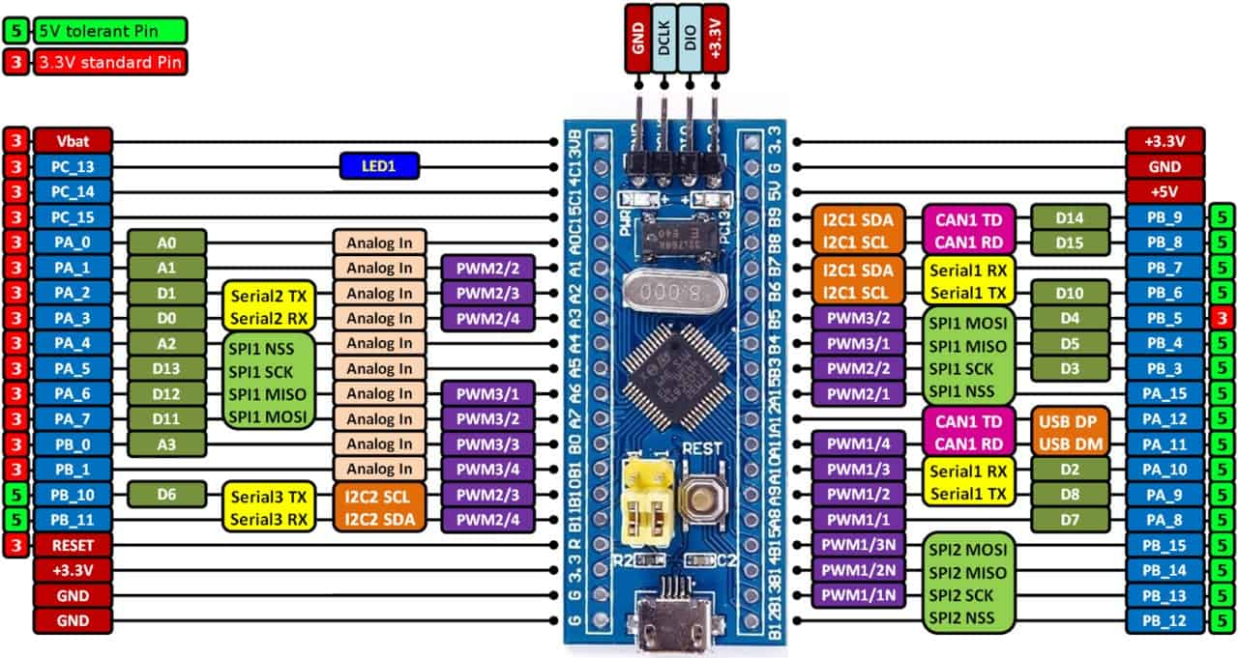

### ****Method to Program STM32 Microcontroller:****

There are 6 methods by which you can program STM32 Microcontroller. The methods are:  
1. STM32duino Bootloader Method  
2. Serial Method  
3. By using ST-Link Debugger  
4. By BMP (Black Magic Pro)  
5. Jlink Method  
6. By HID bootloader 2.0

But here we will be using the most popular method, i.e Serial Method to program STM32 Microcontroller. For this, you need USB to TTL Converter. And we are using FTDI Module to program STM32. The connection diagram between STM32 and USB to TTL is given below.

[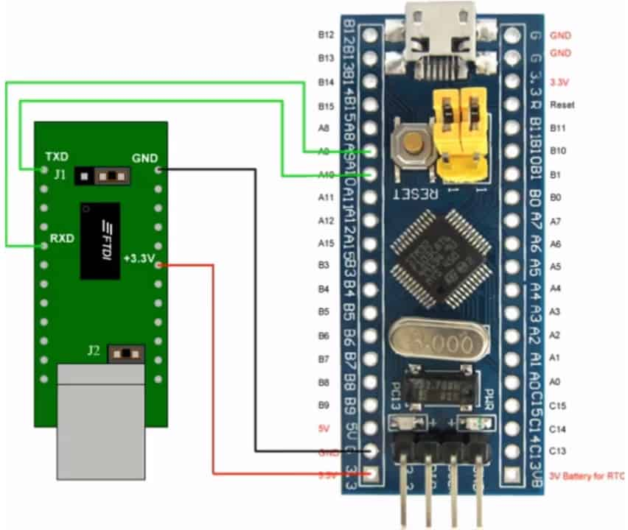](https://how2electronics.com/wp-content/uploads/2019/02/stm32-and-usb-to-ttl-connection-1.jpg)

Connect GND of FTDI to GND of STM32  
Connect 5V/3.3V of FTDI to 5V/3.3V of STM32  
Connect Rx of FTDI to A9 (Tx) of STM32  
Connect Tx of FTDI to A10 (Rx) of STM32